CodeStyle

Use async pipe whenever possible
- Everything inside the Angular App is a stream.
- Angular is based on RxJs library
- Angular HTTP Client produces RxJs Observables
- Distinguish between stream and stream content
- Content is available after subscription
- You can subscribe by .subscribe() in TypeScript or via async pipe in the template
- Using async pipe has many benefits, it
  - Promotes declarative code
  - Handles automatic unsubscription automatic
  - Provides seamless change detection event with standard CD strategy

The shortest path of the list of (data) elements to the screen via async pipe

Service
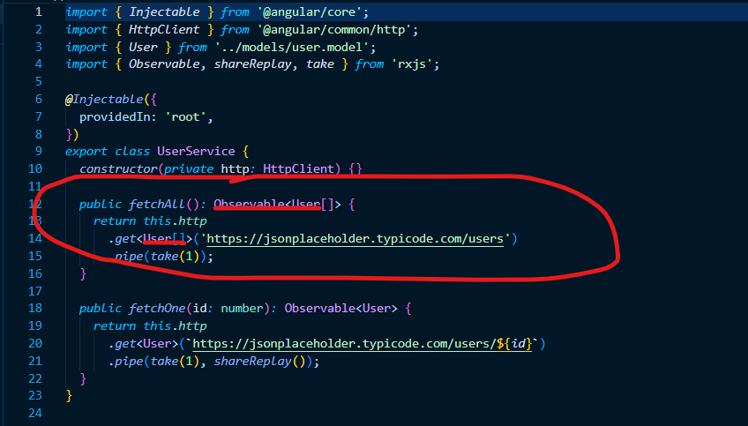
Figure 1 Typical Service handling Api calls
The fechAll procedure returns HttpClient Api (GET) call. The returning value is an Observable<User[]>

Component
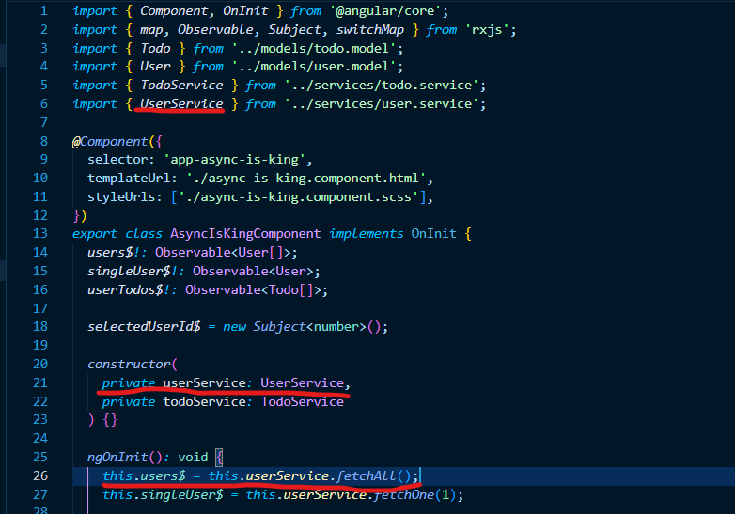
Figure 2 Three lines needed to get data to the template
This is all we need to get data to the template/screen:
- Import service providing Observable containing list/array of data
- Service should be incorporated into component/class via constructor
- fetchAll procedure of UserService to be inserted into public class variable (types should fit)

Template
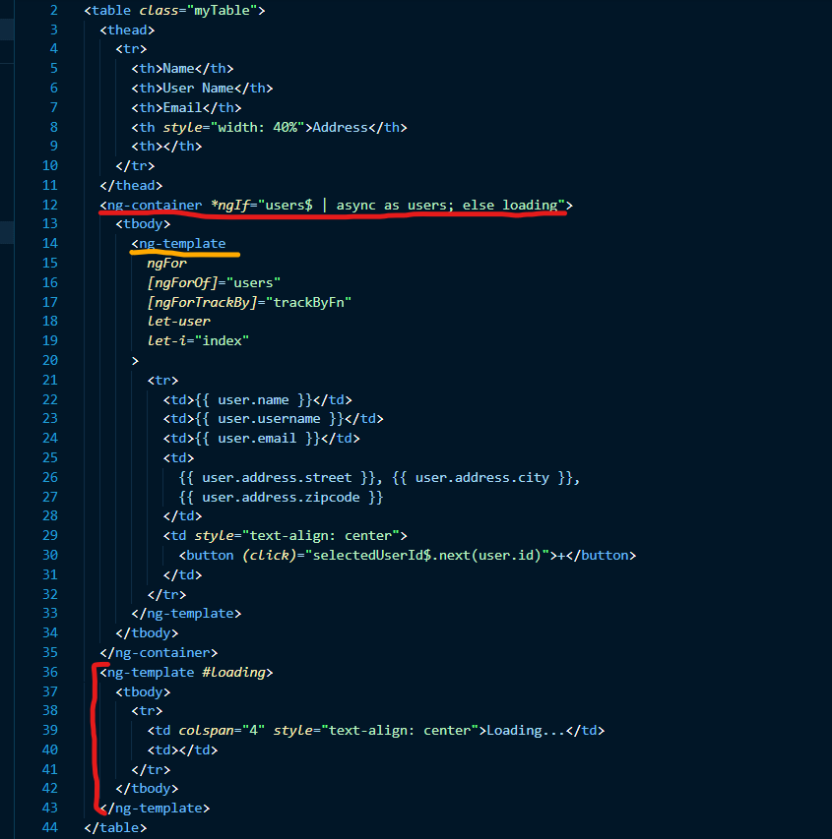
Figure 3 Template for HTML table
Angular structural directive *ngIf provides great way to handle the subscription via async pipe. If the stream contains data the <tbody> is shown. “as users” part of the ngIf statement stores the content of the observable into a template variable users. Users variable does not necessarily be defined in the component code. If the stream is empty or not yet resolved the #loading template is shown. In this case #loading template mimics <tbody> with one-line static “Loading …” message.
NgTemplate is a great way to inject data into the template. Instead of using *ngFor which creates a new html element the ng-template directive just creates scope where data is provided whereas the *ngFor is run on the background.

Showing details wit async pipe
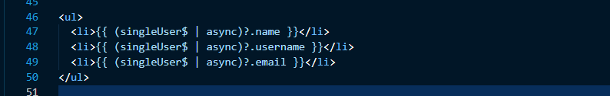
Figure 4 Accessing data property with async pipe
Async pipe can be used to populate the template directly. However, there is a potential performance drawback. There is an existent stream between the template and backend. Every subscription, every async pipe wakes up not only the service result, but also initiates the new http request.
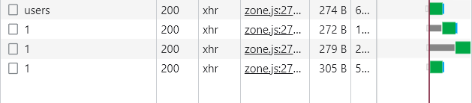
Figure 5 Multiple http request crated

Imagine complicated page/component that can spawn hundreds or thousands of http requests. There is a relatively simple solution to this problem.

RxJs operator shareReplay() to the rescue
shareReplay() operator actually creates a temporary cache that answers subsequent requests without actually creating a http request.
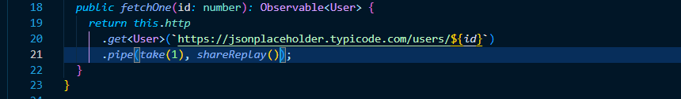
Figure 6 shareReplay RxJs operator introduced
Once shareReplay is introduced the same template produces just one http request that creates the cache. Subsequent subscriptions are satisfied from the cache. 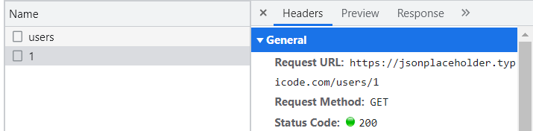

Figure 7 Single http request

Use switchMap to initiate http requests
switchMap belongs into group of RxJs operators that changes the nature of the stream, maps a stream to another stream (flatMap, mergeMap, switchMap and concatMap).
What makes switchMap different from other xxxMap operators? A fundamental feature of the switchMap operator is the ability to stop previous similar streams. If a new request is created based on the switchMap operator before the previous request is fulfilled, for example before the backend responds, the previous request is terminated. This feature can be conveniently used when we do not want abundance of identical asynchronous requests (whose clearance time may vary) to exist at the same time. In such situation, it would be impossible to guarantee that the displayed data are the most recent.
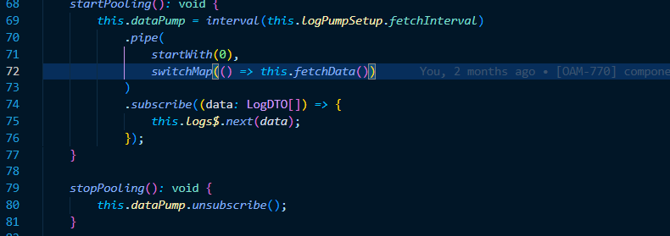
Figure 8 Using switchMap in data pooling
In data pooling, the source of RxJs repetition is the interval operator, which produces a simple stream of values 1,2,3, ... each after a specified time period. This interval stream, like a pendulum, is switch mapped into a repeated call to the backend asking for new data. The switchMap operator guarantees that even if the previous request(s) are not handled within one retry period, the new request kills the previous queries, so the t-1 value will not reach the screen.
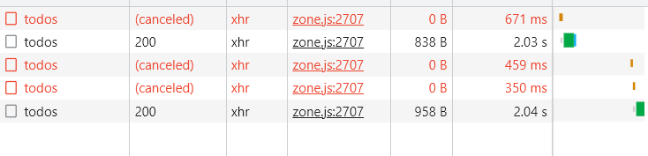
Figure 9 Subsequent request created by switchMap cancels previous http requests

How can we utilize this inside our components? Instead of using function that is requesting additional data for a table row we can use RxJs subject instead.
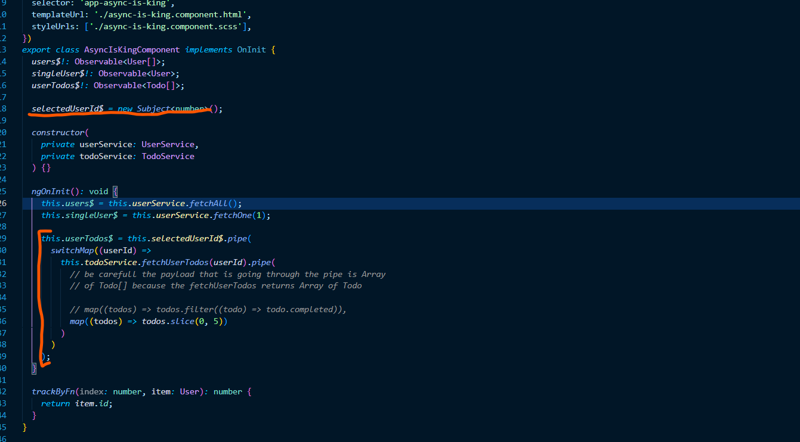
Figure 10 Implementation of switchMap trigger instead of procedure
SelectedUserId$ to be defined as a new RxJs Subject. We are passing the userId to the RxJs subject via
pretty much the same way we’d pass it to the component procedure. Change of the subject internal state wakes up the switchMap operator that calls the Api procedure and passing the user.id value as the parameter. As being said the newest request cancels every previous http request that has reasonable same URI and parameters. There is whole Api to set up the switchMap cancelation strategy but for most cases the default (no parameters) works just fine.

As being said there are other RxJs map operators that can be used to shape the request streams to find the best fit for the active component or set of components. Some of those strategies will be further discussed.

Performance boost via Pipes
Angular weakness is change detection. ZoneJS and ngZone are great tool for developers as every change of every variable is sooner or later displayed on the screen. The drawback is that the change detection system is eager and resource thirsty. You can either modify the change detection strategy to ‘onPush’ and manage all the change detection your own by using ChangeDetectorRef, which may and will cause multiple FE issues or just avoid some known change detections pitfalls.
One simple quick win is to avoid functions that supposed to format the output by using the component procedures. Imagine we have a list of 10 users with detailed model of address (street, city, zip, etc..) and you want to concatenate all those values into string displayed inside the table.
Let’s create the concatAddressFunction that combines street, city and zip values. A console log inside such function is to be triggered avg. 4x more often than necessary needed. In our list of 10 users the addresses are concatenated 40 times.
Let’s create the (Angular) custom pipe with the same logic. Angular pipes are special kind of services mainly used in template to transform or format the output. By default, Angular pipes are pure, which means it is only called when Angular detects a change in the value or the parameters passed to a pipe.
That means the concatenation logic inside the pipe is triggered only 10x.
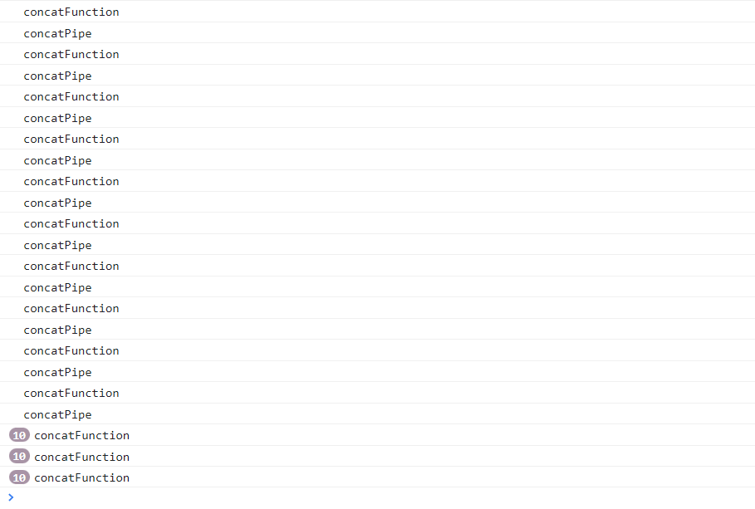
Figure 11 Function vs Angular Pipe
As you can see at the beginning (during the initial rendering) function and the pipe are the same, but then the ZoneJs change detection kicks in and the already drawn values are reevaluated. In the table of 10 lines it makes no difference but with long tables/lists with hundreds of items it can be a real issue. And this is not the end of the story. ZoneJs change detection never dies. Once we added a simple button that increases the value of an independent local variable ZoneJs strikes again. Another two full rounds of concatenations (inside the local functions) is performed again. With nested components it can be real issue.

Sharing state using RxJs BehaviorSubject
Subjects are special type of RxJs Observables which value can be set by code. The difference between Subject and BehaviorSubject (BS) keeps the value that can be always available. Imagine the stream is the weather information/forecast. Subject is FM radio broadcasting that broadcast actual weather info every 15 minutes. User/subscriber can listen the radio but there is chance user need to listen up to 14minutes in order to get the information. The behavior subject is WeatherApp, it is also updated every 15 min. but user sees the last most relevant information every time he/she opens the App.

Sharing state via BehaviorSubject can be done in simple steps
- Create SharedStateService as a singleton inside the whole Angular App
- Define the type or interface of the shared state
- Inside the SharedStateService create a private new BehaviorSubject and set the initial state (empty or minimum viable value)
- Create the public get function that offers the content of BS as an Observable (.asObservable())
- Create public set function overriding the contentment or several discrete functions that sets/overrides just part of the content.
- Inject SharedStateService to components that need to share the state, read and/or write.
- Connect component variable to SharedStateService get function and use it as every other stream of data.
- To change shared state always use SharedStateService public set functions
- Make sure the change of the shared state won’t trigger a loop or even chain reaction

If you want to change the value of isolated parts of the BS, you need to modify the type/interface and make individual properties optional or handle such changes via set of specific functions. In any case, it is advisable to use some immutable library to change the contents of the BS, or at least use the Object.assign() operator.
Immutability is something to consider once dealing with shared state. It is a good idea to keep the BS itself within the "SharedStateService", only as private and not allow components to modify the BS directly. The fact the public get functions offer the BS only as an observable actually means that components do not have access to the BS.next() function.
For the same reason make sure the set functions are so called “Pure Functions”. By definition, a Pure Function is a block of code, that always returns the same result if the same arguments are passed.

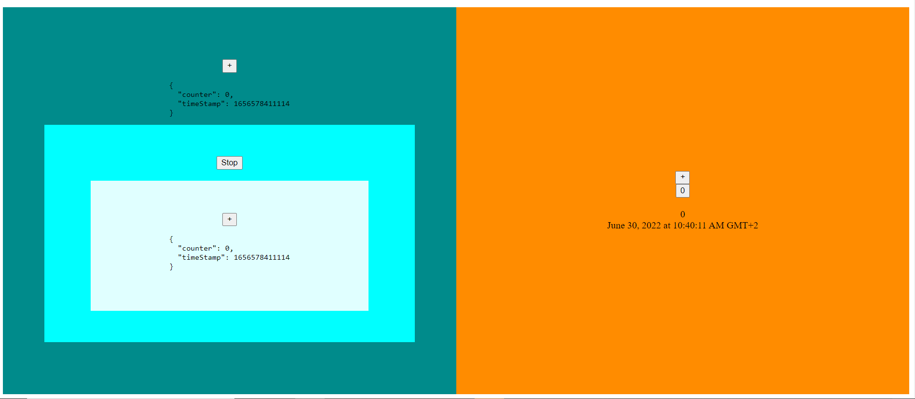
Figure 12 Basic layout

In our example there is a dummy wrapper (ContainerComponent) that holds two macro components (pages). Page A holds ParentComponent and ChildComponent. Each component has imported SharedStateService. Shared state here is very simple and has only two properties (counter, timeStamp).
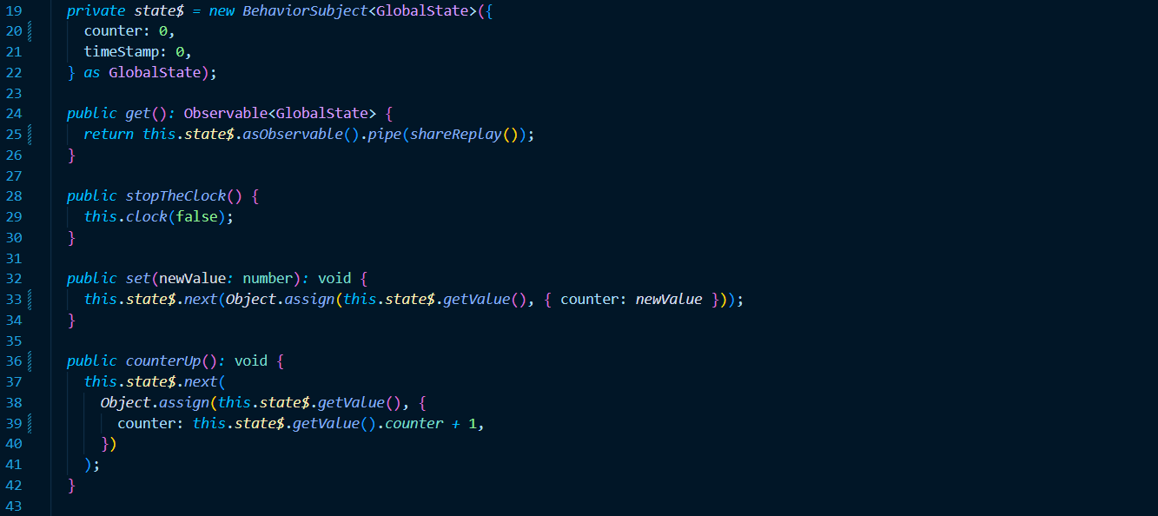
Figure 13 Implementation
New private BehaviorSubject is crated with default values. [19-22]
Get function provides the BehaviorSubject transformed into observable [24-26]
General set function allows to set counter value by using Object.assign() method [32-34]
CounterUp functions is the simples Business Logic possible that adds 1 to the counter value and which is accessible from many components involved [36-42]
There is also simple clock implementation that can switched on and off. Clock produces timestamp value that is shared through the application. In PageBComponent the timestamp value is used by async pipe and the standard Angular DatePipe is used to render human readable result.

The implementation inside the component is very simple and it almost identical in all components
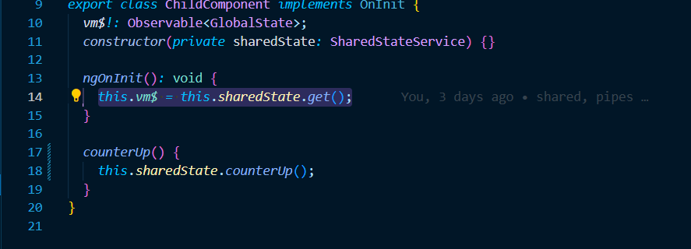
Figure 14 Shared state on the component side
SharedStateService is injected and used in the constructor.
Shared state provided by get() function is inserted into local variable.
If needed SharedStateService public set functions can be accessible from the component template.

